# **Department of Computer Science and Engineering Islamic University of Technology (IUT)** A subsidiary organ of OIC

# 

# **Laboratory Report**

# CSE 4412 : Data Communication and Networking Lab

## 

## **Name: Md Muktadir Mazumder Student ID: 190042136 Section: Lab Group - B Semester: 4th Academic Year: 2020-21**

**Date of Submission:13/01/22**

**Lab 4**

### **Title:** Observation of ARP events and lecture on Logical Addressing. **Objective**:

1. Understand how the physical address of a node in the same network is found when the source only knows the logical address.
2. Understand the necessity of hierarchical addressing compared to flat addressing.
3. Understand classful addressing of IPv4 Addressing.
4. Understand the subnet mask.

### **Devices/ software Used**:

1. Device: Personal Computer
2. Software: Cisco Packet Tracer

### **Diagram of the experiment:**

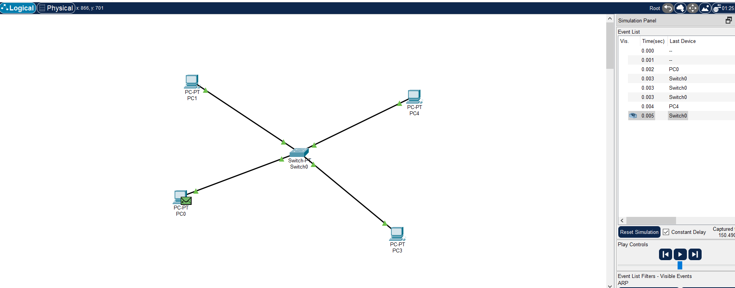

### **Experiment Set Up Description:**

To set up the environment for experiment in Cisco Packet Tracer; the following steps are followed:

1. At first, select four end devices (PCs) and a switch and connect them.
2. After that, assign specific IPv4 Address to all the end devices as well as the subnet mask.
3. Using the inspect sign, observe the ARP table of PC0 and PC4.
4. Using command prompt sent ping from PC0 to PC4.

Created 4 end devices (PC) and a Switch. Connected the end devices with the switch. Assigned

IPV4 address and and Subnet Mask to the end devices. After that inspected the arp table of

PC0 and PC4 by using the inspect sign . There seems to be no entries on either of them. Sent a

ping signal from PC0 to PC4 using the command prompt. Then check the simulation mode to

see the Destination of the packet.

### **Observation**:

After setting up the environment, observe the simulation mode to see the destination of the packets.

From the simulation mode, following scenarios have been observed:

1. ARP Protocol have been observed.
2. After the completion of ping request, table is updated.
3. PC4 only receives the ping request for using switch and all other end devices ignore the ping request.
4. ARP table of PC0 gets updated as PC4 sends back a ping.

### **Challenges:**

The ARP protocol should be selected in the event list.Needed to observe the entries of ARP table by running the “arp-a” command. **By the grace of Almighty Allah, the experiment was done successfully. Though there were some login issues into Cisco Packet Tracer before the start of the experiment.**

**Answer the Following Questions**

1. What is flat addressing and hierarchical addressing? Why is IPv4 address a hierarchical addressing?
2. What are the ranges of ip addresses in class A, B, C.
3. What is a subnet mask? How to determine the network address and broadcast address of a network from an IP address and subnet mask? What are the default subnet mask of a class A, B, C network.

### **Answers**

Answer to the Question No. 01:

**Flat Addressing:** Flat Addressingis organized into a single group. It is not divided into parts.

**Hierarchical Addressing:** Hierarchical Addressing is organized into numerous sub-groups. Its basically divided into a number of parts and also easier to routing.

IPv4 address is a hierarchical addressing because it identifies a network and make it easier to route messages from source to destination. Besides, it holds four octets and network and host address are classified.

Answer to the Question No. 02:

|  |  |
| --- | --- |
| **Class** | **Ranges** |
| A | 0-127 |
| B | 128-191 |
| C | 192-223 |

Answer to the Question No. 03:

**Subnet Mask:** A subnet mask is a 32-bit number created by setting host bits to all 0s and setting network bits to all 1s.

**Determination of Network Address and Broadcast Address of a Network from an IP Address:**

To Determine the Network Address:

Step 01: Write the given IP Address in Binary format.

Step 02: Write the subnet mask in Binary form.

Step 03: Perform logical AND operation between corresponding octets of IP Address and subnet mask.

Step 04: Convert the result back to Decimal format and this will be Network Address.

To Determine the Broadcast Address:

Step 01: Write the given IP Address in Binary format.

Step 02: Write the subnet mask in Binary form.

Step 03: Perform logical OR operation between corresponding octets of IP Address and the inverse of the subnet mask.

Step 04: Convert the result back to Decimal format and this will be Broadcast Address.

**Default Subnet mask of a class A, B, C network:**

|  |  |
| --- | --- |
| **Class** | **Default Subnet Mask** |
| A | 255.0.0.0 |
| B | 255.255.0.0 |
| C | 255.255.255.0 |